SMART WATER FOUNTAIN

**“Discover the Future of Hydration with Our Smart Water Fountain!**

**Stay refreshed and connected with our cutting-edge Smart Water Fountain. This innovative device offers instant access to crisp, purified water, all while seamlessly integrating with your smartphone. Track your daily water intake, set hydration goals, and receive reminders to stay on top of your health. Say goodbye to disposable plastic bottles and join the eco-conscious movement. Upgrade to the Smart Water Fountain today and redefine the way you hydrate!”**

**1. Real-time Water Fountain Monitoring:**

**- Implement a system to monitor water fountains in real-time.**

**- Collect data on water flow rates, usage patterns, and water quality.**

**- Ensure data is accessible through a centralized platform.**

**2. Efficient Water Usage:**

**- Optimize water fountain operation to minimize water wastage.**

**- Develop algorithms to control fountain usage based on demand.**

**- Implement timers and sensors to turn off fountains when not in use.**

**3. Malfunction Detection:**

**- Create a system for early detection of fountain malfunctions or leaks.**

**- Utilize sensors and automated alerts to notify maintenance teams.**

**- Reduce downtime and water loss due to system failures.**

**4. Resident Awareness:**

**- Develop a user-friendly mobile or web application.**

**- Provide residents with real-time information on fountain locations and status.**

**- Educate users on responsible water usage and conservation practices.**

**5. Data Analysis and Reporting:**

**- Implement data analytics tools to analyze usage patterns.**

**- Generate reports and insights for decision-makers.**

**- Use historical data to identify trends and make informed decisions.**

**6. Sustainability:**

**- Ensure the project aligns with sustainability goals.**

**- Investigate the use of eco-friendly materials for fountain construction.**

**- Promote water conservation and environmental awareness among residents.**

**7. Scalability:**

**- Design the system with scalability in mind to accommodate future expansion.**

**- Consider the addition of more fountains and features as needed.**

**- Ensure the system can adapt to changing technology standards.**

**8. Cost Efficiency:**

**- Manage project costs effectively to ensure it remains within budget.**

**- Identify cost-saving opportunities through efficient technology choices.**

**- Evaluate the return on investment (ROI) in terms of water savings and reduced maintenance expenses.**

**9. Stakeholder Collaboration:**

**- Foster collaboration with local authorities, residents, and maintenance teams.**

**- Gather feedback to continuously improve the system.**

**- Establish clear communication channels to address concerns and suggestions.**

**10. Regulatory Compliance:**

**- Ensure the project complies with local water usage regulations.**

**- Obtain necessary permits and approvals for the installation and operation of water fountains.**

**- Stay updated on relevant water conservation laws and standards.**

**These objectives collectively aim to create a smart water fountain management system that enhances efficiency, sustainability, and user awareness while contributing to responsible water usage and conservation.**

**1. **Sensor Selection:\*\***

**- Identify the types of sensors required, such as flow rate sensors, pressure sensors, and water quality sensors.**

**- Choose sensors with the appropriate accuracy, reliability, and durability for outdoor use.**

**2. **Sensor Placement:\*\***

**- Determine optimal sensor locations on each water fountain.**

**- Place flow rate sensors at the water source and outlet to measure water consumption accurately.**

**- Position pressure sensors to monitor water pressure in the fountain system.**

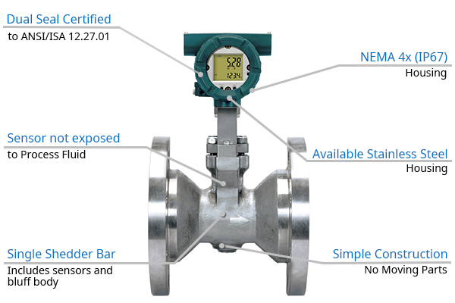 **- Install water quality sensors to ensure the safety and quality of the water.**

**3. **Power Supply:\*\***

**- Select a power source for the IoT sensors, considering options like battery-powered sensors, solar panels, or wired connections.**

**- Ensure the chosen power supply can provide continuous operation and is resistant to weather conditions.**

**4. **Communication Protocols:\*\***

**- Decide on communication protocols for the sensors, such as Wi-Fi, cellular, or LoRaWAN.**

**- Ensure compatibility with the centralized monitoring system.**

**5. **Data Transmission Frequency:\*\***

**- Define how often sensor data should be transmitted (e.g., real-time, hourly, daily).**

**- Balance data frequency with power consumption to optimize sensor performance.**

**6. **Data Security:\*\***

**- Implement robust security measures to protect sensor data from unauthorized access or tampering.**

**- Use encryption and authentication protocols to secure data transmission.**

**7. **Data Storage and Processing:\*\***

**- Establish a data storage strategy for collected sensor data.**

**- Plan for data processing and analysis to derive actionable insights.**

**8. **Calibration and Maintenance:\*\***

**- Regularly calibrate sensors to ensure accurate measurements.**

**- Implement a maintenance schedule for sensor checks, cleaning, and replacements as needed.**

**9. **Alerts and Notifications:\*\***

**- Set up thresholds for sensor data to trigger alerts in case of anomalies (e.g., leaks, low water pressure).**

**- Configure notifications to be sent to relevant personnel or maintenance teams.**

**10. **Scalability:\*\***

**- Design the sensor deployment strategy to accommodate future expansion with additional fountains or sensors.**

**- Ensure that the centralized system can handle an increased number of sensors.**

**11. **Integration with Centralized System:\*\***

**- Establish a connection between the IoT sensors and the centralized monitoring platform.**

**- Define data formats and protocols for seamless integration.**

**12. **User Interface:\*\***

**- Create a user-friendly interface for administrators to monitor sensor data.**

**- Include visualization tools and dashboards for easy data interpretation.**

**13. **Compliance with Regulations:\*\***

**- Ensure that sensor deployment and data collection comply with relevant data privacy and environmental regulations.**

**14. **Testing and Validation:\*\***

**- Conduct thorough testing of the sensor network before full deployment.**

**- Validate sensor accuracy and reliability in real-world conditions.**

**15. **Documentation:\*\***

**- Maintain comprehensive documentation for sensor deployment, including sensor specifications, placement maps, and maintenance records.**

**Careful planning and execution of IoT sensor deployment will enable accurate monitoring of public water fountains, supporting efficient water usage and maintenance while enhancing user awareness of water conservation efforts.**

**[04/10, 12:52 pm] *…..😎 AᵗᵗɴʙU…. 🔥*: Certainly, here are notes for designing a mobile app interface that displays real-time parking availability to users:**

**\*\*User-Friendly Interface:\*\***

**- Prioritize a user-friendly design with an intuitive and clutter-free layout.**

**- Use a familiar and easy-to-navigate menu structure.**

**\*\*Map Integration:\*\***

**- Incorporate an interactive map displaying parking locations and their real-time availability.**

**- Use clear visual cues, such as color coding, icons, or markers, to differentiate between available and occupied spaces.**

**\*\*Location Services:\*\***

**- Utilize GPS and location services to provide users with parking information tailored to their current location.**

**- Implement an option for users to manually input their destination for parking recommendations.**

**\*\*Real-Time Updates:\*\***

**- Ensure parking availability data is updated in real-time to provide accurate information to users.**

**- Establish a reliable system for receiving and processing real-time data from parking sensors or authorities.**

**\*\*Filtering and Sorting:\*\***

**- Allow users to filter parking options based on criteria like distance, price, and availability.**

**- Provide sorting options to help users easily find the most suitable parking spot.**

**\*\*Parking Details:\*\***

**- Include comprehensive information about each parking facility, including rates, hours of operation, and capacity.**

**- Integrate photos, reviews, and ratings to help users make informed choices.**

**\*\*Navigation Integration:\*\***

**- Seamlessly integrate navigation services (e.g., Google Maps) for step-by-step directions to selected parking locations.**

**- Ensure users can easily switch between the parking app and their preferred navigation app.**

**\*\*Reservation and Payment:\*\***

**- Enable users to reserve parking spaces in advance through the app.**

**- Implement secure in-app payment options for parking fees to streamline the process.**

**\*\*User Profiles:\*\***

**- Offer user profile creation to save preferences, payment methods, and booking history.**

**- Implement a login system to provide personalized experiences and enable easy booking management.**

**\*\*Notifications:\*\***

**- Send push notifications to alert users of nearby available parking spaces, expiring reservations, or updates regarding their selected parking spot.**

**- Notify users of any changes or disruptions in parking facilities, such as closures or maintenance.**

**\*\*Accessibility Features:\*\***

**- Ensure the app adheres to accessibility guidelines, making it usable for individuals with disabilities.**

**- Include features like voice commands and screen reader compatibility.**

**\*\*Feedback and Support:\*\***

**- Include a feedback mechanism for users to report issues, submit suggestions, or request assistance.**

**- Offer customer support options within the app, such as a chat support feature.**

**\*\*Privacy and Security:\*\***

**- Prioritize user data privacy and implement robust security measures for handling payment information.**

**- Clearly communicate the app’s privacy policy and data handling practices to users.**

**\*\*Offline Functionality:\*\***

* **Provide limited offline functionality, allowing users to access recent parking information even without an internet connection, including viewing previously accessed parking details and navigation directions.**

**\*\*Promotions and Discounts:\*\***

**- Feature promotions, discounts, and loyalty programs to incentivize app usage and reward regular users.**

**- Notify users of special offers or discounts available at nearby parking facilities.**

**\*\*Multi-Platform Compatibility:\*\***

**- Develop the app for both iOS and Android platforms to reach a wider user base.**

**- Ensure a consistent user experience and functionality across different devices and operating systems.**

**\*\*Testing and Optimization:\*\***

**- Conduct thorough testing to identify and resolve any bugs or performance issues before and after app launch.**

**- Continuously optimize the app based on user feedback and usage data to improve the user experience.**

**\*\*Scalability:\*\***

**- Design the app’s infrastructure to handle increased user traffic and data as the user base grows.**

**- Plan for scalability in terms of server capacity and data storage capabilities.**

**Creating a mobile app interface based on these notes will help users easily find parking spaces, reduce congestion, and improve their overall urban mobility experience.**

**[04/10, 12:54 pm] *…..😎 AᵗᵗɴʙU…. 🔥*: Integration Approach: IoT Sensor Data Transmission to Water Fountain Status Platform**

**1. **Sensor Protocols:\*\***

**- Identify the communication protocols that IoT sensors will use to transmit data. Common options include Wi-Fi, Bluetooth, LoRaWAN, cellular, or a combination of these.**

**2. **Data Format Standardization:\*\***

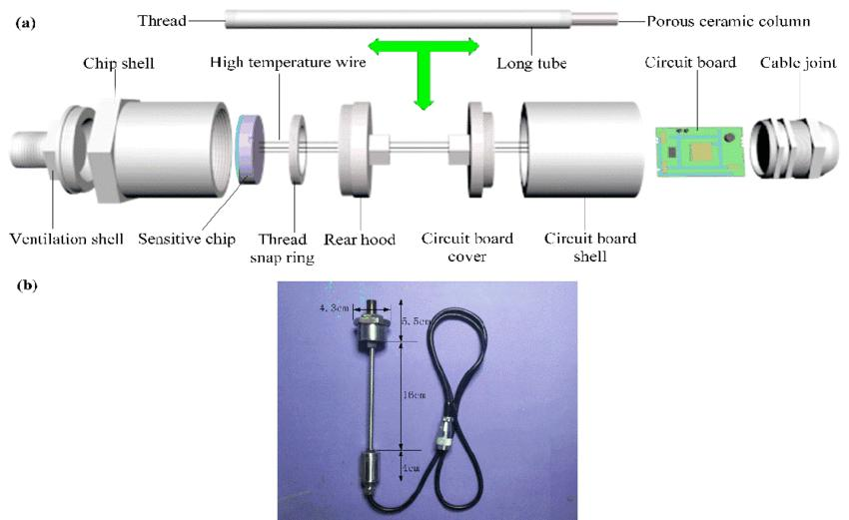 **- Define a standardized data format or protocol for the IoT sensors to follow when sending information to the platform. This ensures consistency in data structure.**

**3. **Sensor Network Topology:\*\***

**- Determine the network topology for the IoT sensors. Options include a star topology (sensors connect directly to a central hub), mesh topology (sensors can relay data), or a hybrid approach.**

**4. **Gateway Devices:\*\***

**- Consider using gateway devices or concentrators to collect data from multiple sensors and transmit it to the platform. Gateways can bridge communication protocols if needed.**

**5. **Data Encryption and Security:\*\***

**- Implement strong data encryption and security measures to protect sensor data during transmission. This is crucial to prevent unauthorized access or tampering.**

**6. **Frequency of Data Transmission:\*\***

**- Decide how often the sensors will transmit data. Real-time monitoring may require frequent updates, while periodic reporting may be sufficient for some parameters.**

**7. **Data Validation and Error Handling:\*\***

**- Implement data validation checks to ensure the accuracy and integrity of the data being sent.**

**- Develop error-handling mechanisms to address communication failures or sensor malfunctions.**

**8. **Cloud or Local Processing:\*\***

**- Determine whether data should be processed and analyzed locally by the sensors or sent directly to a cloud-based platform for processing.**

**9. **Edge Computing:\*\***

**- Explore the possibility of implementing edge computing capabilities in sensors to perform initial data analysis and reduce the amount of data sent to the platform.**

**10. **APIs and Middleware:\*\***

**- Develop APIs or middleware that facilitate communication between the sensors and the water fountain status platform.**

**- Ensure compatibility with the chosen communication protocols.**

**11. **Scalability:\*\***

**- Design the integration approach to scale easily as the number of sensors and data volume increase. Consider load balancing and resource management.**

**12. **Data Buffering and Queuing:\*\***

**- Implement data buffering and queuing mechanisms to handle temporary network disruptions or platform unavailability, ensuring data is not lost.**

**13. **Quality of Service (QoS):\*\***

**- Implement Quality of Service settings to prioritize critical data transmission, especially in scenarios where timely updates are essential.**

**14. **Data Prioritization:\*\***

**- Define which sensor data should be given higher priority during transmission. Critical parameters may need faster reporting than less critical ones.**

**15. **Monitoring and Logging:\*\***

**- Set up monitoring and logging systems to track the performance and health of the sensor network and data transmission.**

**16. **Redundancy and Failover:\*\***

**- Plan for redundancy in data transmission paths and failover mechanisms to ensure continuous operation in case of network failures.**

**17. **Compliance and Regulations:\*\***

**- Ensure that data transmission and handling comply with relevant data privacy and regulatory requirements.**

**18. **Testing and Validation:\*\***

**- Conduct thorough testing and validation of the integration approach to verify data accuracy and reliability.**

**By carefully considering these integration approaches, you can establish a robust and efficient system for IoT sensors to send real-time data to the water fountain status platform, enabling effective monitoring and management of the water fountains.**